[insert your company’s logo or letterhead here]
To: [Supervisor name]
From: [Your name]
Re: ASSP Professional Development Conference & Exposition
I am requesting approval to attend Safety 2023, the American Society of Safety Professionals Professional Development Conference & Exposition.
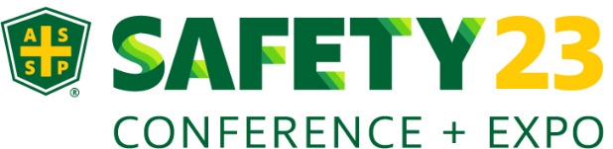
As a safety professional, I look to have proficiency in environmental management, ergonomics, industrial hygiene, product safety, Workers’ Compensation, construction safety and organizational management, in addition to the more traditional aspects of safety management and engineering. The ASSP educational conference encompasses all this and so much more.
I believe my attendance will be a cost-effective investment for the company. For three days, I will be engrossed in over 20 hours of education. I will attend multiple concurrent sessions, panels and interact with fellow professionals. I am especially interested in the topics relevant to our company’s situation, such as:
[Session 1 Name Here]
[Session 2 Name Here]
[Session 3 Name Here]
Additionally, if we register a team of eight or more, we can take advantage of discounted group rates.
OSH professionals will come together to learn about best practices, case studies and the latest technology. ASSP is IACET-accredited and can provide continuing education credits. The conference has been providing introductory, intermediate and advanced-level training for professionals over the past 60 years and is known for providing first-class education and training - it is truly the industry’s “must-attend” event.
Additionally, I will have access to a best-in-class online platform that will help me organize my schedule, access session handouts and re-watch key sessions for 60 days after the event.
Upon completion, I can host an "Key Takeaways from Safety 2023” presentation. This will allow me to share best practices and lessons learned from leading experts and practitioners in the field for others to benefit from my conference experience as well.
My goal is to constantly grow as an individual and I strive to become a more proficient safety professional. I hope you agree that my professional development and increased safety knowledge is a worthwhile investment to our organization.
Thank you for your consideration,

(insert name here)

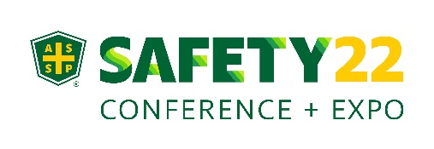
Professional Development Request for ASSP Safety 2023
Submission Date: (insert date here)
Name: (insert name here)
Conference Dates: June 5 – 7, 2023
Number of Days: 3
Website: https://safety.assp.org
What events/programs/activities will be taking place during this time, and who will cover them in your absence?
(insert here)
Conference Fees
Registration: (cost based on registration date)
Pre and/or Post Conference Courses: (costs range from $300-$1500 per course)
Total Cost: (insert cost here)

Supervisor Review & Approval
Professional Certification
Professional Development
Work Required
_____________________________________ __________________
Supervisor Date
_____________________________________ __________________
Supervisor Date

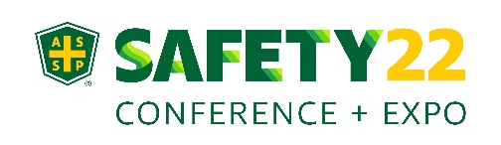
Upon Return/Completion

1. What sessions/classes/workshops or events did you attend?

2. What did you learn in each session?

3. How will you use the information gained?

4. What other information did you gain that can be used or passed on to others?

